____ Final Analysis Report

Table of Contents

I. Descriptive Statistics of Per Protocol Sample 2
a. Protocol Defined Inclusion and Exclusion Criteria 2
b. Descriptive Study and Sample Characteristics of Intent-to-Treat (ITT) Sample 2
c. Current Therapies and Co-morbidities 3
d. Coaches 3
e. Reported Adverse Events 3
II. Baseline Descriptive Statistics and Group Differences 4
a. Baseline Descriptive Statistics for all Per Protocol Subjects 4
III. Final Per Protocol Analysis 5
a. PP End of Study Statistics for all Subjects 5
Table 5. 5
b. PP Primary Outcome Measure Analysis 6
c. PP Secondary Outcome Measure Analysis 6
IV. Written Report 10

- Descriptive Statistics of Per Protocol Sample

Protocol Defined Inclusion and Exclusion Criteria

Per Protocol Definition:

ITT Definition:

Inclusion Criteria:
- 4 to 10 years 11 months of age (up to 11th birthday at randomization)
- Properly completed participant informed consent (and assent if clinically appropriate)
- Diagnosis of ASD documented by a qualified clinician according to DSM-5 criteria and confirmed by ADOS or ADI-R
- Receiving ABA therapy at Cortica
- Able to tolerate VR headset
- Females of childbearing potential must have a negative urine pregnancy test at the Screening Visit
Exclusion Criteria:
- A history of photosensitive epilepsy, or photoparoxysmal response on electroencephalogram (EEG)
- Active diagnosis of migraine headache or migraine variant (abdominal migraine, cyclic vomiting syndrome), not adequately controlled
- History of balance disorder including vertigo, motion sensitivity, or balance disorder
- Primary sensory impairment (blindness, deafness)
- Motor disorder that would interfere with VR engagement

  - Descriptive Study and Sample Characteristics of Per Protocol (PP) Sample

Table 1.
 | Group A | Group B | p-value
 | (N=5) | (N=6) | p-value
 | Mean (SD /(%) | Mean (SD)/(%)
Age | 70 (14) | 69 (13) | >0.9
Gender
Male | 5 (100%) | 6 (100%)
Clinic Site (%) |  |  | 0.048
Irvine | 3 (60%) | 1 (17%)
Irvine: Laguna Niguel | 0 (0%) | 1 (17%)
San Diego | 2 (40%) | 0 (0%)
Torrance | 0 (0%) | 4 (67%)
Race (%) |  |  | >0.9
Asian | 2 (40%) | 3 (50%)
Other | 1 (20%) | 1 (17%)
White | 2 (40%) | 2 (33%)
Ethnicity |  |  | >0.9
Hispanic or Latino | 2 (40%) | 3 (50%)
Not Hispanic or Latino | 3 (60%) | 3 (50%)
VABS Group (%) |  |  | 0.5
Mild-Moderate | 3 (60%) | 5 (83%)
Severe | 2 (40%) | 1 (17%)

  - Current Therapies and Co-morbidities
Table 2.
 | Group A, N=5 | Group B, N=6 | p-value
ABA | 5 (100%) | 6 (100%)
OT | 5 (100%) | 4 (67%) | 0.5
ST | 5 (100%) | 6 (100%)
PT | 4 (80%) | 1 (17%) | 0.08
MT | 4 (80%) | 4 (67%) | >0.9
ABA Frequency (sessions/week) | 4.40 (0.89) | 3.83 (0.68) | 0.3
OT Frequency (sessions/week) | 2.20 (0.45) | 2.00 (0.00) | 0.5
ST Frequency (sessions/week) | 2.20 (0.45) | 2.08 (1.20) | 0.6
PT Frequency (sessions/week) | 1.13 (0.25) | 1.00 (NA) | >0.9
MT Frequency (sessions/week) | 1.13 (0.25) | 1.75 (0.50) | 0.11

  - Coaches

Table 3.

Characteristic | A, N = 5¹ | B, N = 6¹ | p-value²
Coach |  |  | 0.5
CL & TS | 1 (20%) | 0 (0%)
LA | 1 (20%) | 0 (0%)
LK | 0 (0%) | 1 (17%)
RD | 0 (0%) | 1 (17%)
ShPe | 1 (20%) | 0 (0%)
SN | 0 (0%) | 1 (17%)
SyPe | 0 (0%) | 2 (33%)
TS | 2 (40%) | 1 (17%)

  - Reported Adverse Events

2 Adverse Events Reported in the A Group (ALL ENROLLED SUBJECTS)
- FLO-021: Interim Visit 1
  - Ear Infection
  - Not related to intervention
- FLO-021: End of Study Visit 1
  - Grade 3 (severe): medically significant but not immediately life0threatening; hospitalization or prolongation of hospitalization indicated; disabling; limiting self-care activities of daily living.
  - Not related to intervention
  - Dropped out

2 Adverse Events Reported in the B Group
- FLO-009 @ Interim Visit 3 Date: 2023-05-25
  - Grade 1 (mild): asymptomatic or mild symptoms; clinical or diagnostic observations only; intervention not indicated.
  - Description: “Increased mood swings”
  - Possibly related to intervention
  - Dropped out
- FLO-015
  - No description provided
  - Included in PP analysis

- Baseline Descriptive Statistics and Group Differences

  - Baseline Descriptive Statistics for all Per Protocol Subjects

Table 4.
 | Group A  (N=5) | Group B  (N=6) | p-values
 | Mean (SD)  [min-max] | Mean (SD)  [min-max]
Kaufman BIQ | 61.40 (27.58) [40.00-104.00] | 66.33 (28.66) [40.00-102.00] | >0.9
CARS Composite | 33.10 (5.98) [24.00-38.00] | 29.42 (3.81) [23.50-33.50] | 0.3
AIM
Composite | 221.60 (62.90) [133.00-282.00] | 181.50 (51.96) [133.00-253.00] | 0.2
Social | 26.80 (6.72) [20.00-34.00] | 21.83 (6.11) [15.00-32.00] | 0.14
Communication | 33.60 (11.63) [22.00-51.00] | 30.50 (7.61) [22.00-40.00] | >0.9
Peer Interaction | 24.80 (6.18) [15.00-32.00] | 17.00 (7.54) [10.00-27.00] | 0.14
Repetitive Behavior | 39.00 (16.36) [19.00-56.00] | 36.33 (12.89) [19.00-52.00] | 0.9
Atypical Behavior | 32.60 (12.44) [16.00-46.00] | 23.33 (8.94) [15.00-40.00] | 0.2
Vineland-3
Composite | 64.00 (9.70) [54.00-77.00] | 73.83 (9.45) [56.00-83.00] | 0.14
Socialization | 64.40 (10.45) [48.00-75.00] | 77.00 (11.17) [58.00-92.00] | 0.055
Communication | 59.20 (17.66) [44.00-83.00] | 73.33 (17.07) [40.00-89.00] | 0.3
Daily Living Score | 67.40 (10.11) [52.00-79.00] | 77.17 (12.56) [63.00-95.00] | 0.3
Motor | 76.00 (9.08) [68.00-89.00] | 80.00 (6.87) [70.00-89.00] | 0.5

- Final Per Protocol Analysis

  - PP End of Study Statistics for all Subjects

Table 5.
 | Group A  (N=5) | Group B  (N=6) | p-values
 | Mean (SD)  [min-max] | Mean (SD)  [min-max]
AIM
Composite | 213.60 (63.43) [133.00-276.00] | 174.83 (39.26) [151.00-252.00] | 0.4
Social | 25.80 (7.66) [17.00-33.00] | 22.83 (6.05) [14.00-31.00] | 0.6
Communication^ | 36.40 (7.89) [26.00-48.00] | 27.00 (5.66) [20.00-36.00] | 0.067
Peer Interaction | 20.00 (8.49) [11.00-31.00] | 15.00 (3.52) [10.00-19.00] | 0.5
Repetitive Behavior | 38.20 (17.46) [21.00-58.00] | 36.33 (14.45) [25.00-64.00] | 0.8
Atypical Behavior | 29.40 (14.43) [13.00-47.00] | 22.00 (5.02) [16.00-29.00] | 0.5
Vineland-3
Composite^ | 61.00 (11.51) [51.00-74.00] | 75.17 (14.84) [49.00-95.00] | 0.082
Socialization | 63.80 (11.08) [52.00-79.00] | 75.67 (14.51) [48.00-88.00] | 0.2
Communication | 56.80 (18.75) [36.00-81.00] | 76.00 (25.29) [34.00-106.00] | 0.2
Daily Living Score | 61.60 (14.72) [38.00-74.00] | 79.00 (14.31) [61.00-98.00] | 0.2
Motor | 74.40 (15.58) [57.00-97.00] | 78.83 (12.21) [62.00-97.00] | 0.6
CARS Composite | 31.90 (6.10) [25.00-37.00] | 29.75 (7.86) [20.00-42.50] | 0.7

  - PP Primary Outcome Measure Analysis

 | Group A  (N=5) |  | Group A Change Score | Group B  (N=6) |  | Group B Change Score | Interaction F-Statistics
 | Pre-Mean (SD) | Post-Mean (SD) |  | Pre-Mean (SD) | Post-Mean (SD)
AIM Composite | 221.60 (62.90) | 213.60 (63.43) | -8 | 181.50 (51.96) | 174.83 (39.26) | -6.67 | 0.01 (p=.93)

*Indicates a significant Group×Time (pre-post) interaction test statistic at p<.05 for
^Indicates a trend-level Group×Time (pre-post) interaction test statistic at p<.10 for
† Indicates a significant estimated marginal means for post-hoc pairwise comparison test of within-group change at p<.05
Yellow indicates an average decrease in AIM score surpassing the minimal clinical difference for improvement threshold (-4.5)

  - PP Secondary Outcome Measure Analysis

 | Group A  (N=5) |  | Group A Change Score | Group B  (N=6) |  | Group B Change Score | Interaction F-Statistics
 | Pre-Mean (SD) | Post-Mean (SD) |  | Pre-Mean (SD) | Post-Mean (SD)
AIM
Social | 26.80 (6.72) | 25.80 (7.66) | -1 | 21.83 (6.11) | 22.83 (6.05) | 1 | 0.24 (p=.63)
Communication | 33.60 (11.63) | 36.40 (7.89) | 2.8 | 30.50 (7.61) | 27.00 (5.66) | -3.5 | 3.66 (p=.09)^
Peer Interaction | 24.80 (6.18) | 20.00 (8.49) | -4.8 | 17.00 (7.54) | 15.00 (3.52) | -2 | 0.47 (p=.51)
Repetitive Behavior | 39.00 (16.36) | 38.20 (17.46) | -0.8 | 36.33 (12.89) | 36.33 (14.45) | 0 | 0.02 (p=.90)
Atypical Behavior | 32.60 (12.44) | 29.40 (14.43) | -3.2 | 23.33 (8.94) | 22.00 (5.02) | -1.33 | 0.26 (p=.62)
Vineland-3
Composite | 64.00 (9.70) | 61.00 (11.51) | -3 | 73.83 (9.45) | 75.17 (14.84) | 1.34 | 1.94 (p=.20)
Socialization | 64.40 (10.45) | 63.80 (11.08) | -0.6 | 77.00 (11.17) | 75.67 (14.51) | -1.33 | 0.03 (p=.86)
Communication | 59.20 (17.66) | 56.80 (18.75) | -2.4 | 73.33 (17.07) | 76.00 (25.29) | 2.67 | 0.83 (p=.34)
Daily Living Score | 67.40 (10.11) | 61.60 (14.72) | -5.8† | 77.17 (12.56) | 79.00 (14.31) | 1.83 | 7.54 (p=.02)*
Motor | 76.00 (9.08) | 74.40 (15.58) | -1.6 | 80.00 (6.87) | 78.83 (12.21) | -1.17 | 0.01 (p=.92)
CARS Composite | 33.10 (5.98) | 31.90 (6.10) | -1.2 | 29.42 (3.81) | 29.75 (7.86) | 0.33 | 0.27 (p=.62)

*Indicates a significant Group×Time (pre-post) interaction test statistic at p<.05 for
^Indicates a trend-level Group×Time (pre-post) interaction test statistic at p<.10 for
† Indicates a significant estimated marginal means for post-hoc pairwise comparison test of within-group change at p<.05
Yellow indicates an average decrease in AIM score surpassing the minimal clinical difference for improvement threshold (-4.5)

Figure 1a. Error Bars Reflecting Change in Primary and Secondary Endpoints Across Study
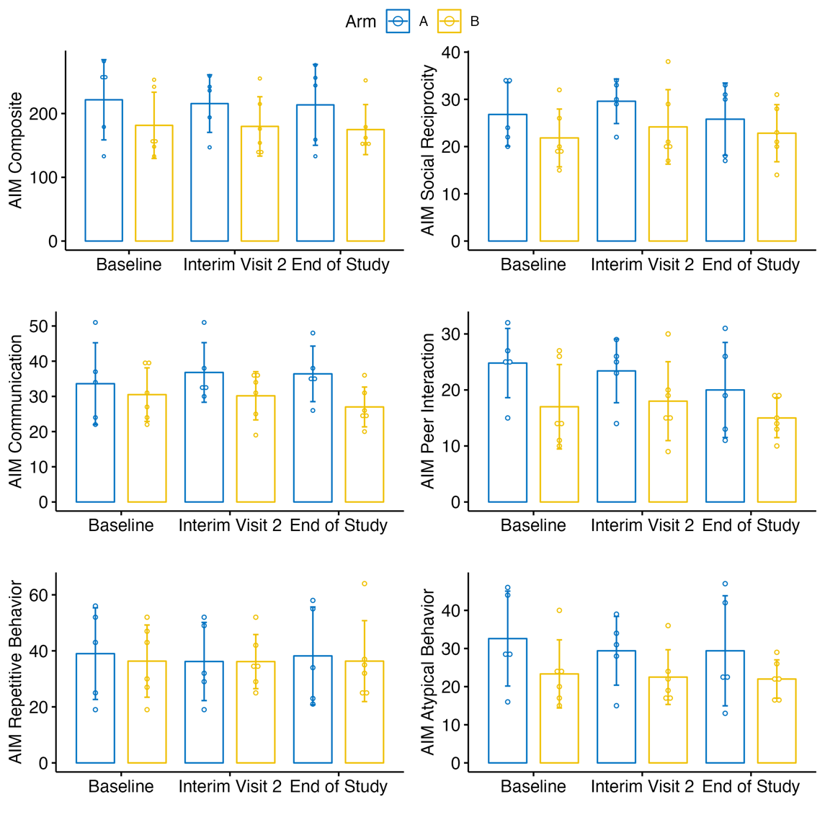
Error bars reflect +/-1 SD from the mean

Figure 1b. Error Bars Reflecting Change in Secondary Endpoints Across Study

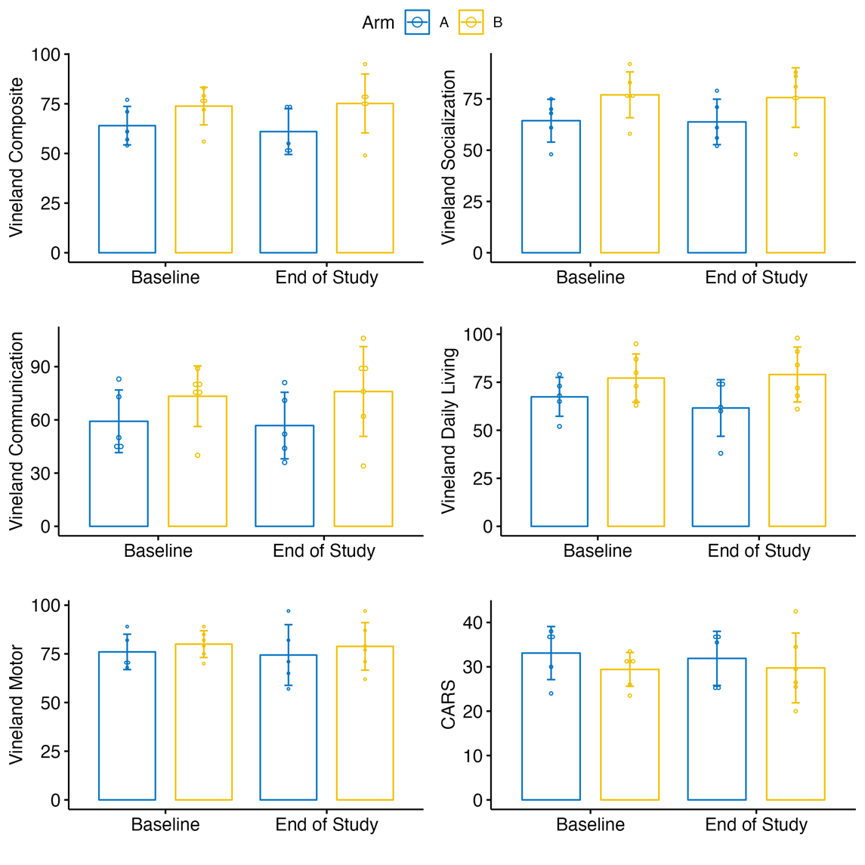

Error bars reflect +/-1 SD from the mean

- Written Report

At the endpoint of the study, there were a total of 11 participants included in the final analysis, with 5 participants in Group A and 6 participants in Group B. All enrolled participants were retained in the per-protocol (PP) analysis if they completed 90% of VR training sessions.
The mean age of participants in Group A was 70 months (SD = 14), while in Group B, it was 69 months (SD = 13). All participants in both groups were male. The distribution of participants across clinic sites varied significantly, with Irvine and San Diego having the highest representation for Group A and Torrance for Group B. In terms of the severity of autism, 60% of Group A participants and 40% of Group B participants had mild to moderate autism based on Vineland-3 scores. There were no significant group differences in race, ethnicity, or autism severity between groups.
All participants in both groups received concomitant Applied Behavior Analysis (ABA) and Speech therapy. Occupational therapy (OT) and music therapy (MT) were also commonly used in both groups. Physical therapy (PT) was used in 80% of Group A, but only 1 subject in group B was in PT. The average frequency of weekly therapy sessions did not vary significantly.
The distribution of coaches across each group was variable. However, there is no indication of systematic imbalance in coaching distribution based on insignificant p-values from Fisher’s exact test.
During the study, two adverse events were reported in Group A involving participant FLO-021. The first event occurred during the interim visit and was classified as an ear infection not related to the intervention. The second event occurred for this participant during their end-of-study visit and was classified as severe but not related to the intervention. Two adverse events were reported in Group B. The first event occurred for participant FLO-009 during the interim visit and was classified as a grade 1 (mild) event, indicating asymptomatic or mild symptoms possibly related to the study intervention. The specific adverse event reported was "increased mood swings." The second event occurred for participant FLO-015 at the end-of-study visit; however, no further details were provided. Only FLO-015 was retained in the analysis; the other two dropped out of the study.
Descriptive statistics were calculated at baseline for the Kaufman Brief IQ (KBIT), Childhood Autism Rating Scale (CARS), Autism Impact Measure (AIM), and Vineland Scales of Adaptive Behavior (Vineland-3). With the exception of the Vineland-3 socialization subdomain, baseline comparisons between Group A and Group B did not reveal significant differences in these assessments (p > 0.10). At baseline, children in Group A showed lower Vineland socialization scores relative to children in Group B.
Statistics were also calculated at the end-of-study visit as an analysis of intervention effects. At the end-of-study visit, the communication sub-domain of the AIM showed a trend-level group difference effect at p = 0.067. Analysis of means demonstrated that Group B had lower AIM communication impairment scores relative to Group A at the end-of-study visit. It is important to note that there were no significant group differences in these outcomes at baseline.
In the final analysis, the primary outcome was the AIM composite score, and secondary outcomes included the AIM subdomain scores, the Vineland scores, and the CARS composite score. To conduct this analysis, repeated measures ANOVAs with time X treatment terms included were modeled. The primary outcome analysis did not demonstrate any significant time X treatment outcomes, indicating that there were no differences in rates of change between baseline and end-of-study scores between Group A and Group B. The secondary outcome analysis indicated a trend-level time X treatment interaction for the AIM communication subdomain. Group A showed a non-significant increase from baseline to the end-of-study (Δ = 2.8; indicating greater impairment), and Group B showed a non-significant decrease from baseline to the end-of-study (Δ = -3.5; indicating decreased impairment). Additionally, the secondary outcome analysis indicated a significant time X treatment interaction for the Vineland daily living score subdomain. Group A showed a significant decrease from baseline to the end-of-study (Δ = -5.8; indicating increased impairment), and Group B showed a non-significant increase from baseline to the end-of-study (Δ = 1.83; indicating decreased impairment). Pairwise estimated marginal mean post-hoc tests were calculated to evaluate the magnitude and significance of within-group change. The decrease in Group A’s Vineland daily living score (indicating increase impairment) met statistical significance but the decrease Group B’s AIM communication score (indicating decreased impairment) did not.

